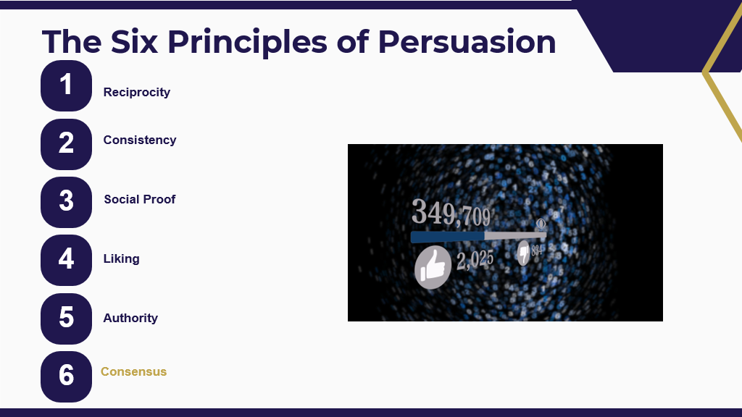
Reciprocity – Give them something, get in return. EX: Here’s a trueU topic. I know you care about this, so here’s this….
Consistency – People like to make things consistent with what they are already doing. Personal Development Plans are an example. How can you tie in trueU to processes/initiatives that are already in place
Social Proof – Show benefits of trueU. Stats, testimonies, metrics, reporting.
Like – if you are liked. Influence on people in general.
Authority – higher level
Consensus – “everyone is doing it” OR not doing the thing….

